STAG SG635L 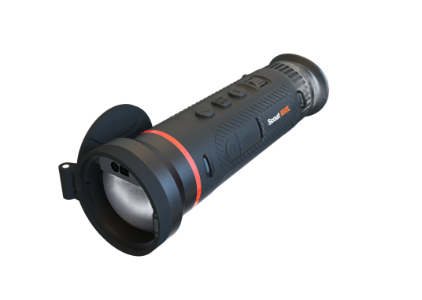

Thermal Monocular

With a native magnification of 3.5x, a high-resolution 384 × 288 detector, and a premium 35 mm F1.0 lens, the SG635L delivers exceptional performance for discerning hunters and long-range observation. Its 7.5°×5.6° field of view and a detection range of up to 2600 m ensure crisp, detailed imagery even in vast, open landscapes, making it the ultimate choice for users seeking professional-grade quality.

Key Features
● High-sensitivity thermal module with NETD ≤ 15 mK (@25° C, F# = 1.0).
● 35 mm, F0.9 lens with thermal detection range up to 2600 m.
● Advanced image enhancement algorithms with 1×, 2×, and 4× digital zoom.
● Built-in 905nm Class 1 laser rangefinder, providing accurate range data up to 1.2 km with ±1m precision.
● 0.49-inch AMOLED display with 1024 × 768 resolution for sharp, clear imagery.
● 1 replaceable 21700 lithium battery offering ≥7.5 hours of continuous operation at 25°C.
● Robust IP67 protection level, designed to withstand harsh field conditions.

n Specification
Item category | STAG SG635L
Thermal Module
Image Sensor | UFPA (VOx)
Resolution | 384×288
Pixel Pitch | 12µm
Frame Rate | 50Hz
NETD | ≤15mk
Spectral Range | 8-14µm
Optical Parameter
Focal length / Aperture | 35mm; F1.0
Field of View | 7.5°×5.6°
Base Magnification | 3.5X
Focusing Mode | Focus Roller
Eye Relief | 20mm
Exit Pupil | 6mm
Diopter | +5D to -5D
Detection Range | 1800m (Human; 3pixels)
Recognition Range | 450m (Human; 12pixels)
Image Display
Screen | AMOLED, 0.49 inch
Resolution | 1920×1080
Screen Brightness Adjustment | Support
Brightness Adjustment | Support
Contrast Adjustment | Support
Image Enhancement | Support
Scene Mode | City;Plain;Forest
Display Mode | Circle;Box
Color Palette | White Hot/Black Hot/Red Hot/Fusion/Golden Hot etc.
Digital Zoom | 1×; 2×; 4×; 8×
Power Supply
Battery type & Number | 1 replaceable 21700 Lithium battery
External Power Supply | DC 5V (USB Type-C)
Power Consumption | ≤1.9W（25℃）
Battery Operating Time | ≥8.5h （25℃）
System
Record Video | Support
Capture Snapshot | Support
Audio Recording | Support
Local Album | Support
Recoil Activation Recording | -
Picture in Picture | Support
Hot Track | Support
Zeroing Adaptation Mode | -
Screen Adaptation | Support
Standby Mode | Support
Ballistic Calculation | -
Ballistic Calibration | -
Distance Measurement | Support
Zeroing Profiles | -
Reticle Pattern | -
Reticle Pattern | -
Aim Point Type | -
Aim Point Colour | -
BC Aim Point Type | -
BC Aim Point Colour | -
Ranging Cursor Type | 3
Ranging Cursor Colour | 3
Peripheral
Electronic Compass | Support
Attitude Sensor | Support
WIFI /APP | Support; 2.4G
Storage | Built-in EMMC (64GB)
Laser Rangefinder | 905nm;Class 1 Laser Safety
Ranging Distance & Accuracy | 1.2 Km*; ±1m
General
Data Transmission Interface | USB (Type-C)
Protection Level | IP67
Operating Temperature | -20°C to +50°C
Max. Recoil | -
Weight（without battery） | ≤645g
Dimension | 201×82×70（mm）

